
SCHOOL OF COMPUTING AND ENGINEERING SCIENCES (SCES)
BACHELOR OF SCIENCE IN ELECTRICAL AND ELECTRONICS ENGINEERING (BSEEE)
SEMESTER TWO: CHEMISTRY LAB 2
By
Mwongela Edward Aribu 142092
Collaborators
Teddy Mbugua - 142776
Mark Mbiriri - 143389
Arnold Injeni - 146279

Abstract
This is a report that contains the data obtained in a laboratory experiment conducted in the Strathmore engineering laboratories by the group members listed above. It covers crystallization, distillation, and extraction.

Table of Contents
Abstract 2
INTRODUCTION 5
1.0.1. Crystallization 5
Objective 5
1.0.2. distillation 5
Objective 5
1.0.3. mixtures and extraction 5
Objective 5
LITERATURE REVIEW 6
Crystallization 6
Distillation 6
Mixtures 7
EXPERIMENT 1: Crystallization 9
METHODOLOGY 9
Requirements 9
Procedure 9
RESULTS AND FINDINGS 10
Experiment 2: Distillation 18
METHODOLOGY 18
Requirements 18
Procedure 18
RESULTS AND FINDINGS 19
Experiment 3: Mixtures and extraction 25
METHODOLOGY 25
Requirements 25
Procedure 25
RESULTS AND FINDINGS 26
REFERENCES 37

Table of figures
Figure 1 8
Figure 2 10
Figure 3 11
Figure 4 12
Figure 5 13
Figure 6 14
Figure 7 15
Figure 8 16
Figure 9 17
Figure 10 17
Figure 11 19
Figure 12 20
Figure 13 21
Figure 14 22
Figure 15 23
Figure 16 24
Figure 17 26
Figure 18 27
Figure 19 28
Figure 20 29
Figure 21 30
Figure 22 31
Figure 23 32
Figure 24 33
Figure 25 34
Figure 26 35
Figure 27 36

INTRODUCTION

1.0.1. Crystallization
Crystallization can be defined as the solidification of a liquid substance into a highly structured solid whose atoms or molecules are placed in a well-defined three-dimensional crystal lattice. The smallest individual part of a crystal is called a unit cell. The crystal is made up of millions of such unit cells.

Objective
Obtain crystals of copper (II) sulphate

1.0.2. distillation
Distillation, or classical distillation, is the process of separating the components or substances from a liquid mixture by using selective boiling and condensation. Dry distillation is the heating of solid materials to produce gaseous products (which may condense into liquids or solids)

Objective
Distil water from the copper (II)sulphate solution

1.0.3. mixtures and extraction
In chemistry, a mixture is a material made up of two or more different chemical substances which are not chemically bonded. A mixture is the physical combination of two or more substances in which the identities are retained and are mixed in the form of solutions, suspensions, and colloids.

Objective
Observe the types of mixtures formed by water and other substances

LITERATURE REVIEW

Crystallization
Crystallization can be defined as the solidification of a liquid substance into a highly structured solid whose atoms or molecules are placed in a well-defined three-dimensional crystal lattice. The smallest individual part of a crystal is called a unit cell. The crystal is made up of millions of such unit cells.
Crystallization processes can be broadly categorized into the following two types:
- Evaporative crystallization
- Cooling crystallization

Salt crystallisation is the most practical use of crystallisation, and it is also the most cost-effective technique to create salt today. Compound purification and crystal synthesis are two further uses for the technology. Water of crystallisation may alternatively be defined as the water molecules that make up a crystal’s structure. They form and crystallise the crystals. CuSO₄. 5H₂O (Copper sulphate) is an antibacterial and antifungal agent that may be used topically. (Crystallization - Definition, Process, Separation Technique, FAQs, n.d.)
- The crystallization of water to form ice cubes and snow.
- The crystallization of honey when it is placed in a jar and exposed to suitable conditions.
- The formation of stalagmites and stalactites (especially in caves).
- The deposition of gemstone crystals.

Distillation
Distillation is the process that occurs when a liquid sample is volatilized to produce a vapor that is subsequently condensed to a liquid richer in the more volatile components of the original sample. The volatilization process usually involves heating the liquid, but it may also be achieved by reducing the pressure or by a combination of both. This can be demonstrated in a simple laboratory distillation apparatus comprising a flask, distillation head, condenser, and sample collector.
The gas is then condensed back into liquid form and collected. Repeating the process on the collected liquid to improve the purity of the product is called double distillation. Although the term is mostly applied to liquids, the reverse process can be used to separate gases by liquefying components using changes in temperature and/or pressure. (Understand How Distillation Works, n.d.)
Types of distillation include simple distillation, fractional distillation (different volatile 'fractions' are collected as they are produced), and destructive distillation (usually, a material is heated so that it decomposes into compounds for collection).
Distillation is used for many commercial processes, such as the production of gasoline, distilled water, xylene, alcohol, paraffin, kerosene, and many other liquids. Gas may be liquefied and separate. For example: nitrogen, oxygen, and argon are distilled from air.

Mixtures
In other words, a mixture is a thing that you get when you combine two substances so that no chemical reaction happens between the substances, and you can separate them once more. In a mixture, every component keeps up its own chemical identity. This can be comprehended as mixtures being the product of mechanically blending the elements or the compound where no chemical bonding is taking place and the chemical properties of all the elements that are involved in the mixing process retain their own chemical properties and makeup.
The characteristics of the mixture are as follows: -
- The two or more substances are existing together despite there being no force acting between them.
- The substances in the mixture are either homogeneous or heterogeneous in nature.
- The proportions of the substances that are present in the mixture vary in an indefinite manner.
- The properties of the individual components determine the properties of the mixture.
- The physical method is the key to separating the substances that are dissolved in the mixtures.
- The characteristics of the substances determine the boiling and the melting point of the mixture.
- There is no change in the energy during the formation of the mixture.
- All the state of matter that is solid, liquid or gases can combine to form a mixture.
Based on the composition of mixtures, they can be divided into two types:
- Homogeneous mixture
- Heterogeneous mixture
Mixtures having a uniform composition all through the substance are called Homogeneous Mixtures.
Mixtures that are not uniform all through are called Heterogeneous Mixtures.
(Mixture, n.d.)

The interaction with the oxygen end of water becomes more important because the lone pair electrons on water make it a Lewis base.
The molecules can form a loosely bound Lewis-type charge transfer complex, in which there is a partial transfer of electrons from the water to the iodine.
I2+OH2l→lδ−I₂⋅⋅⋅lδ+mOH₂
The formation of the complex changes the colour of light absorbed.
(When Iodine (I2) Is Mixed with Water, the Water Dissolves Some Iodine by Forming a Temporary Charge. Does the Oxygen from Water Bond with the Iodine or Does the Hydrogen?, n.d.)
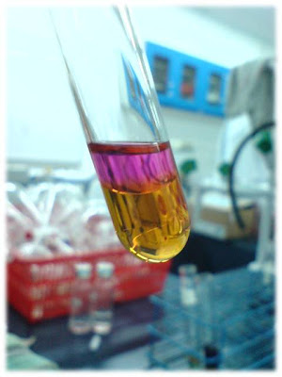
Figure 1
A solution of iodine in water is yellow brown instead of violet.

EXPERIMENT 1: Crystallization

METHODOLOGY

Requirements
Copper (II) sulphate
Beaker
Clamp and stand
Wash bottle
Burner
spatula

Procedure

a) Fix a beaker with the pincers (clamp) in the stand.
b) Pour 20ml of water into the beaker.
c) Light the burner.
d) Pour 4-5 teaspoons of copper (II) sulphate and mix with the rod.
e) After the salt has melted, cool the solution down for 20-30 minutes.

RESULTS AND FINDINGS
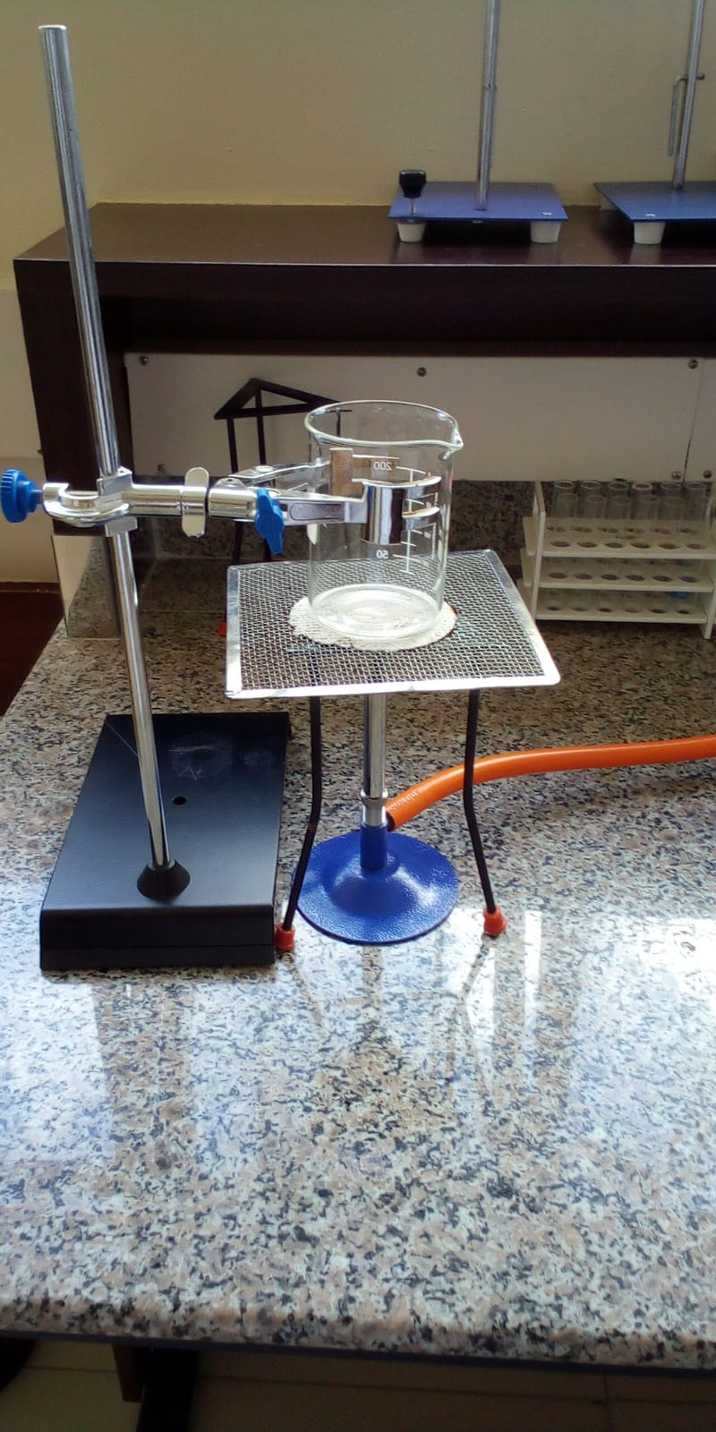
Figure 2
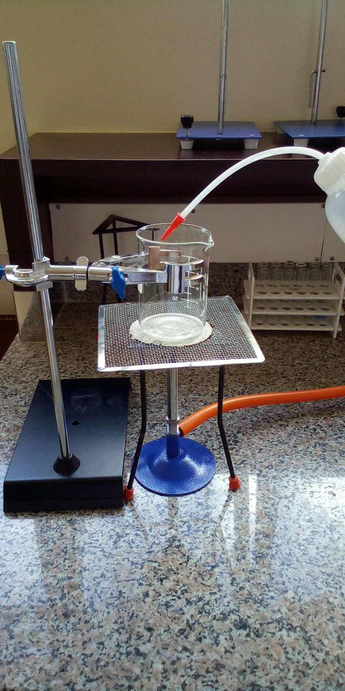
Figure 3
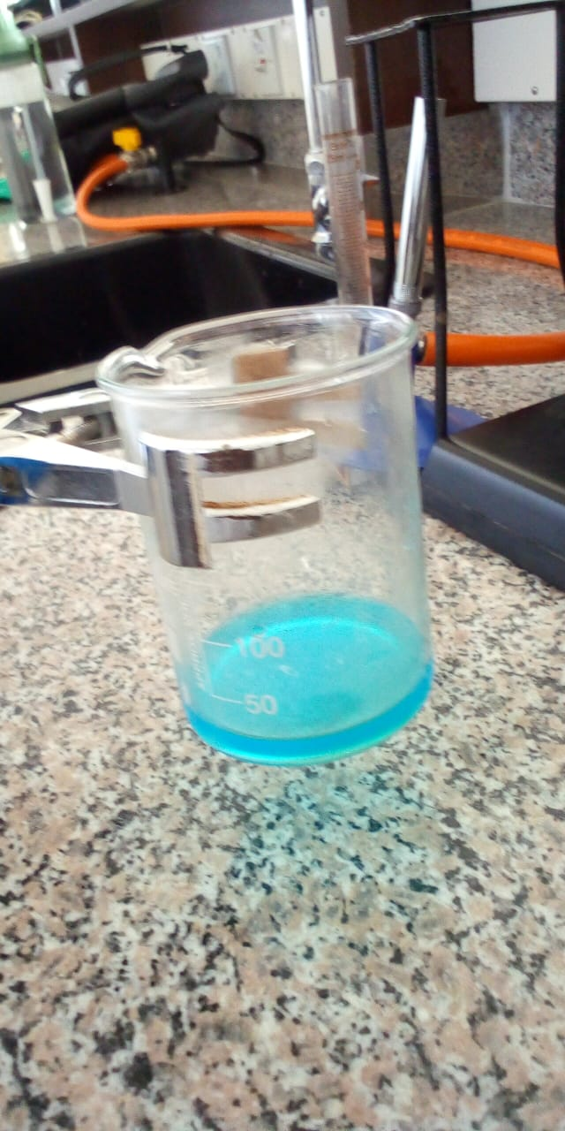
Figure 4
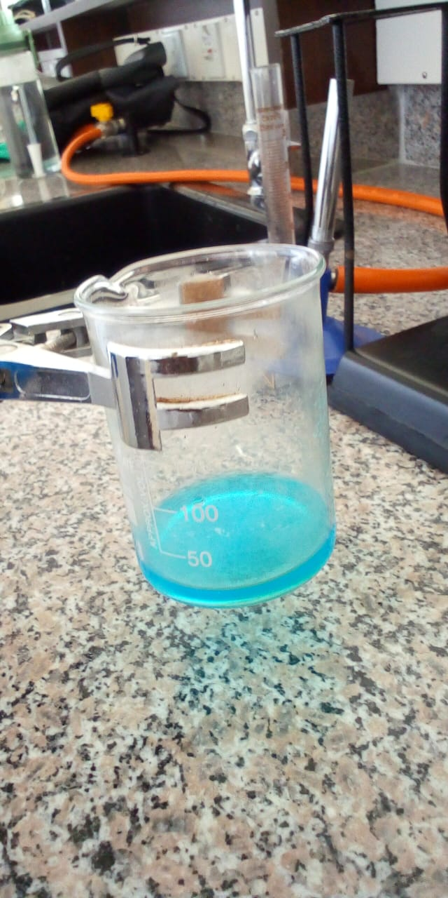
Figure 5
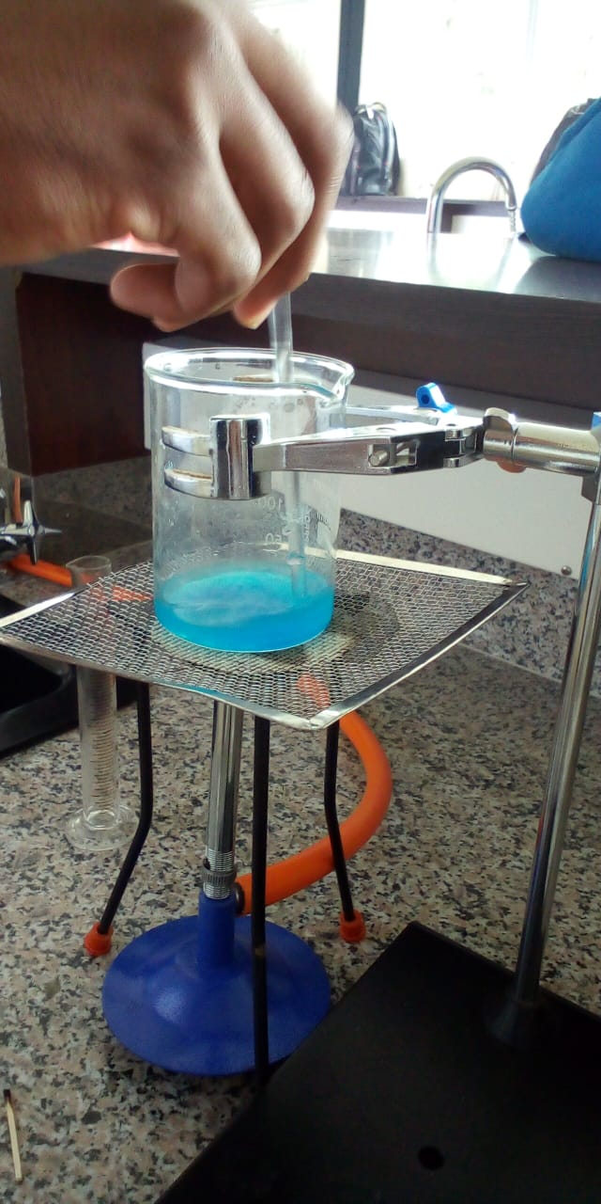
Figure 6
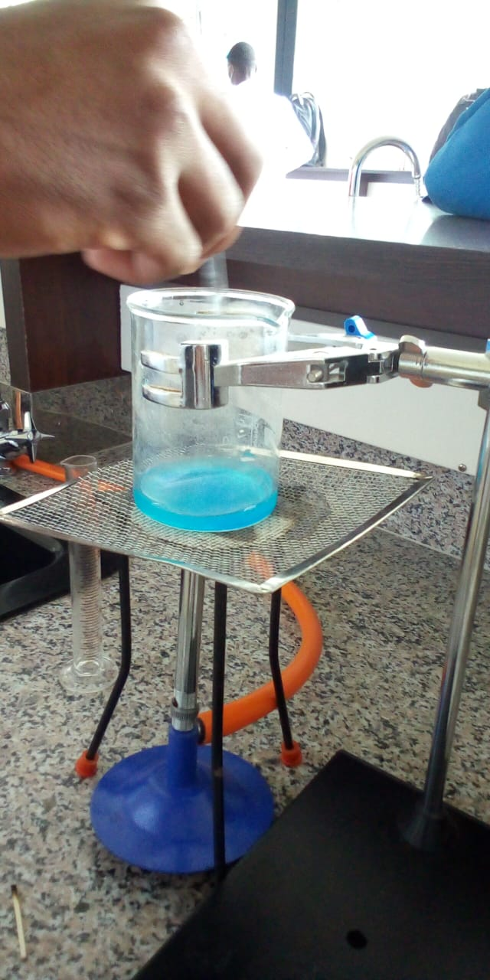
Figure 7

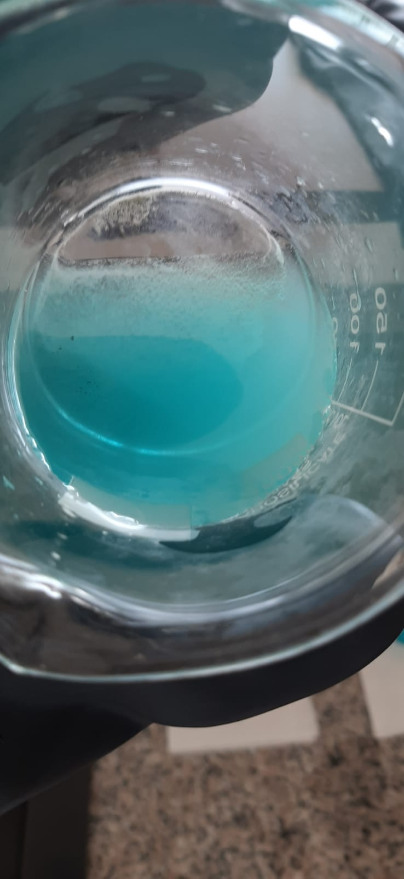
Figure 8
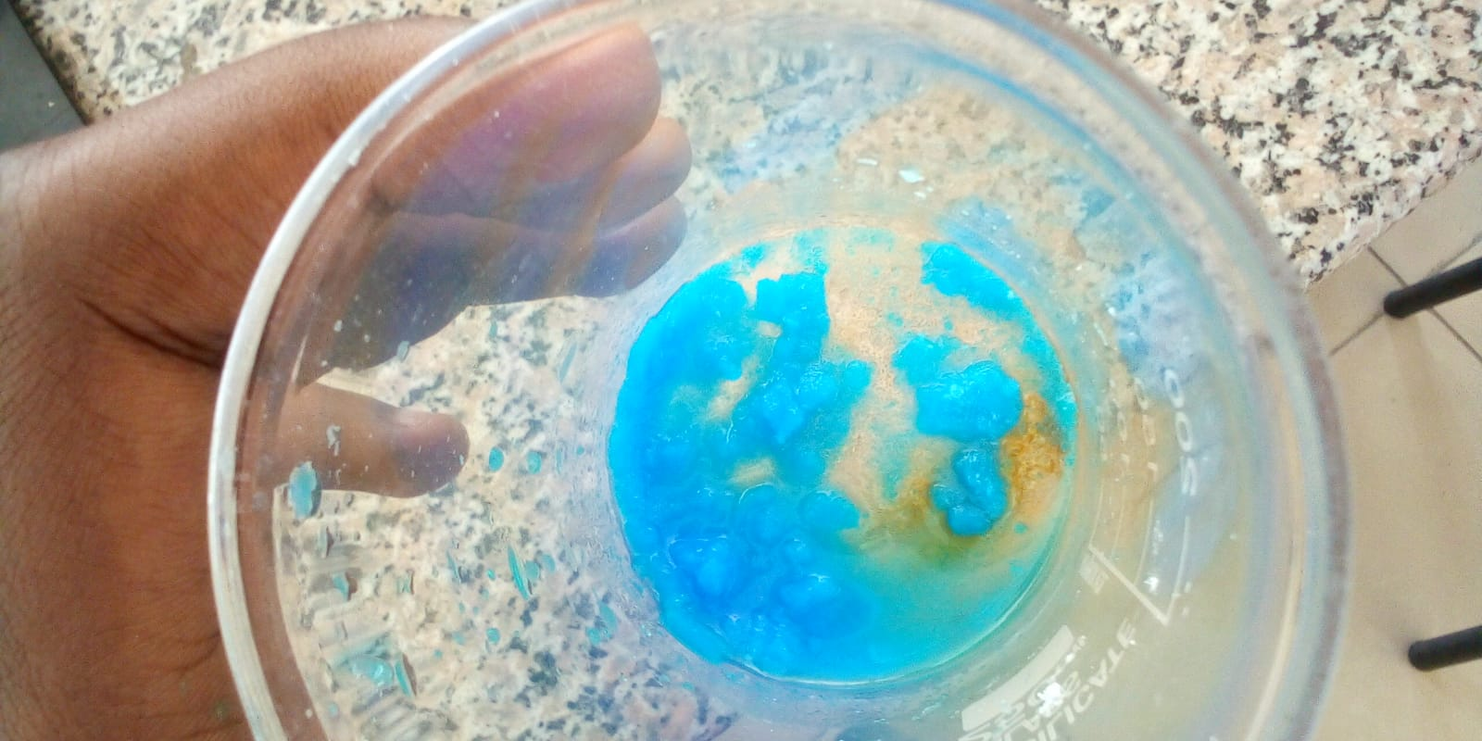
Figure 9

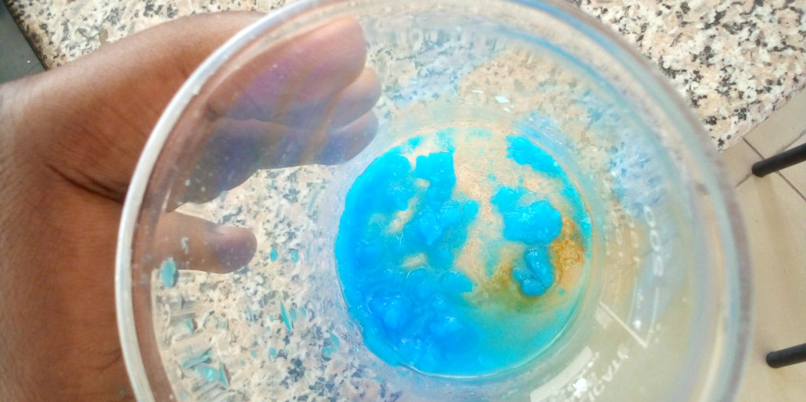
Figure 10
The copper (II) sulphate crystals that were obtained in the end are due to crystallisation through evaporation when the water was heated.

Experiment 2: Distillation

METHODOLOGY

Requirements
1 flask
1 beaker
1 test tube
Spatula
Copper (II) sulphate
Stopper
Tube
burner

Procedure

a) Fix the flask on the stand and pour 30 ml of water.
b) Fill half a beaker with water and insert an empty test tube inside it.
c) Pour a teaspoon of copper (II) sulphate in the flask, cork it and insert the tube of the
stopper in the test tube.
d) Light the burner and wait for the solution to start boiling.
e) Collect some millimetres of distilled water in the test tube, blow out the burner and
cool down.

RESULTS AND FINDINGS
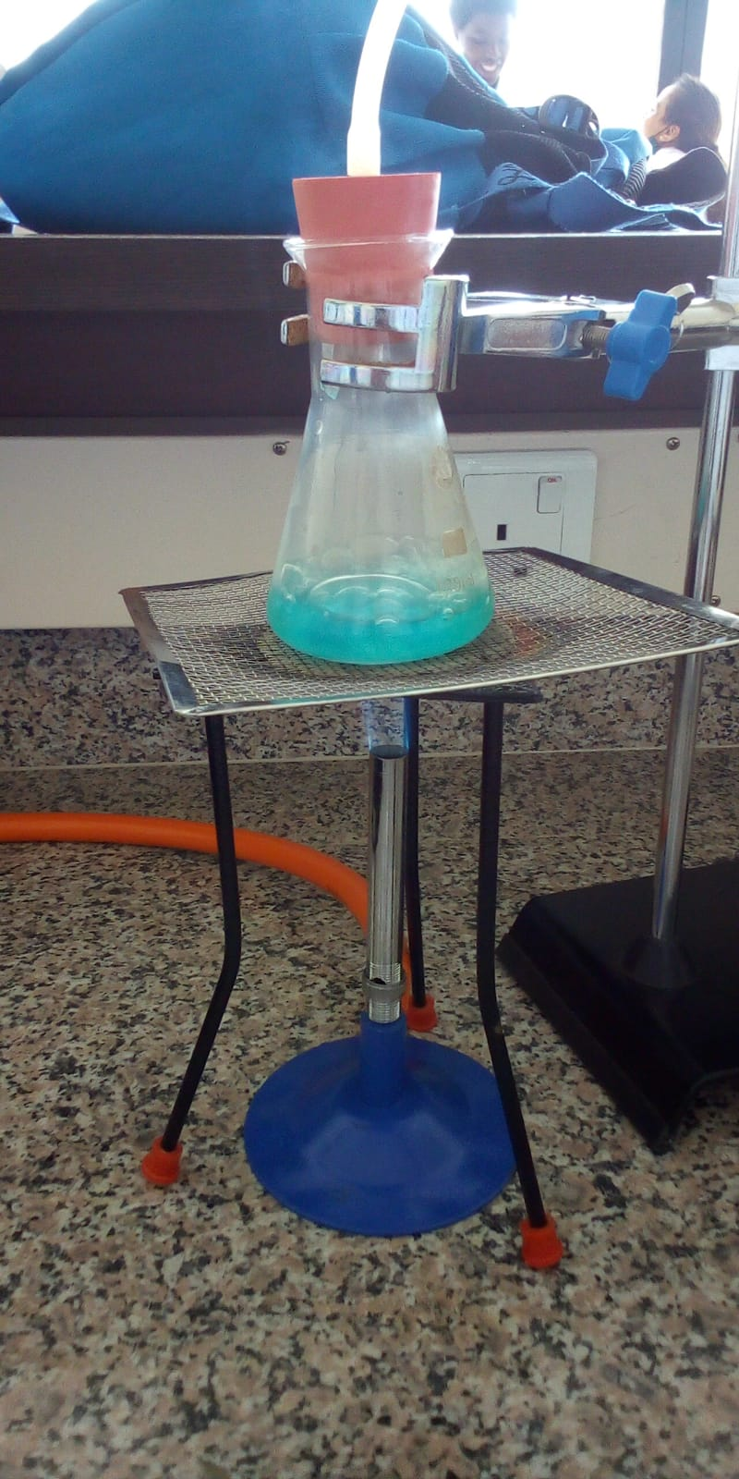
Figure 11
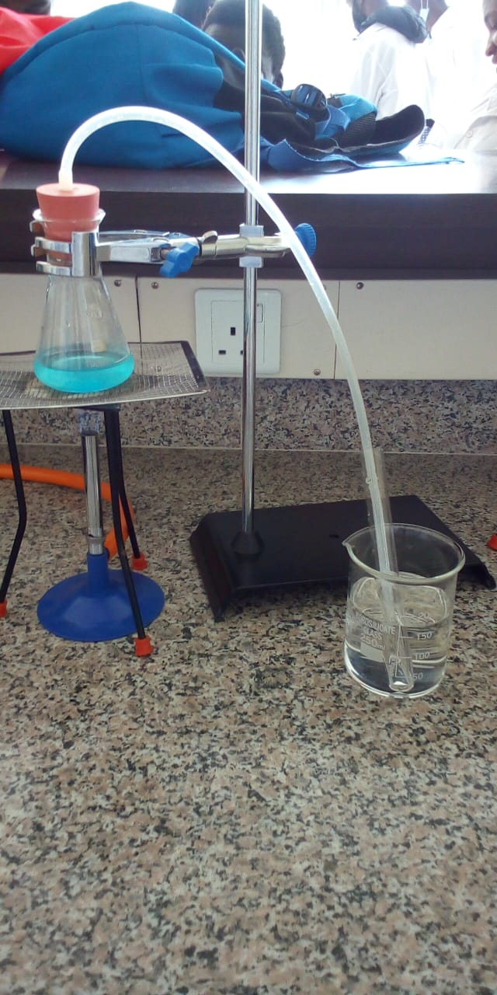
Figure 12
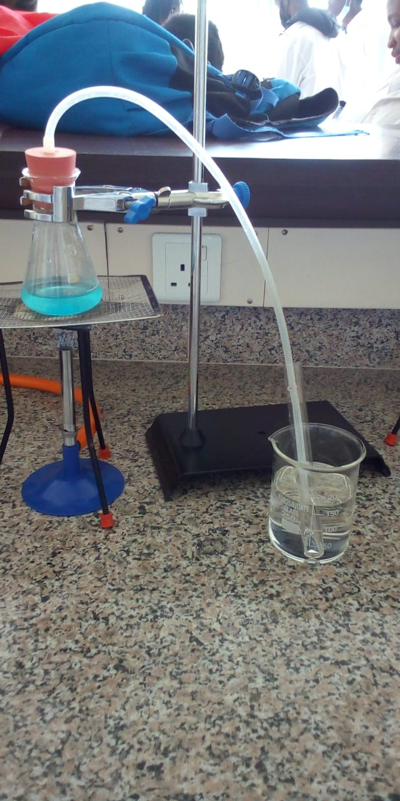
Figure 13
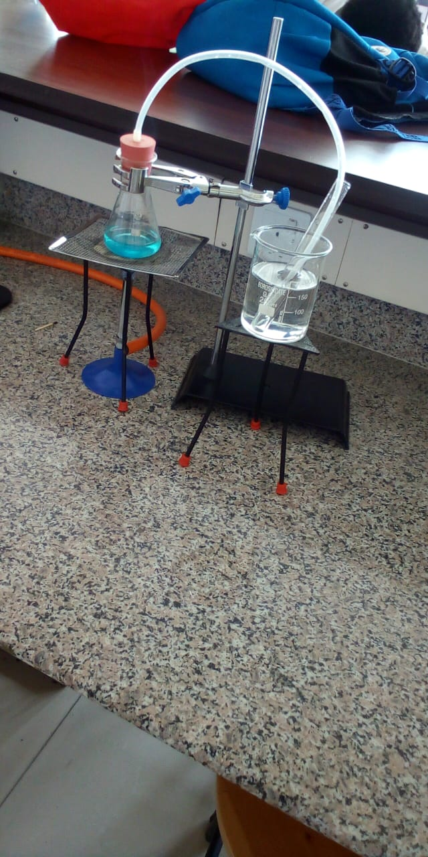
Figure 14
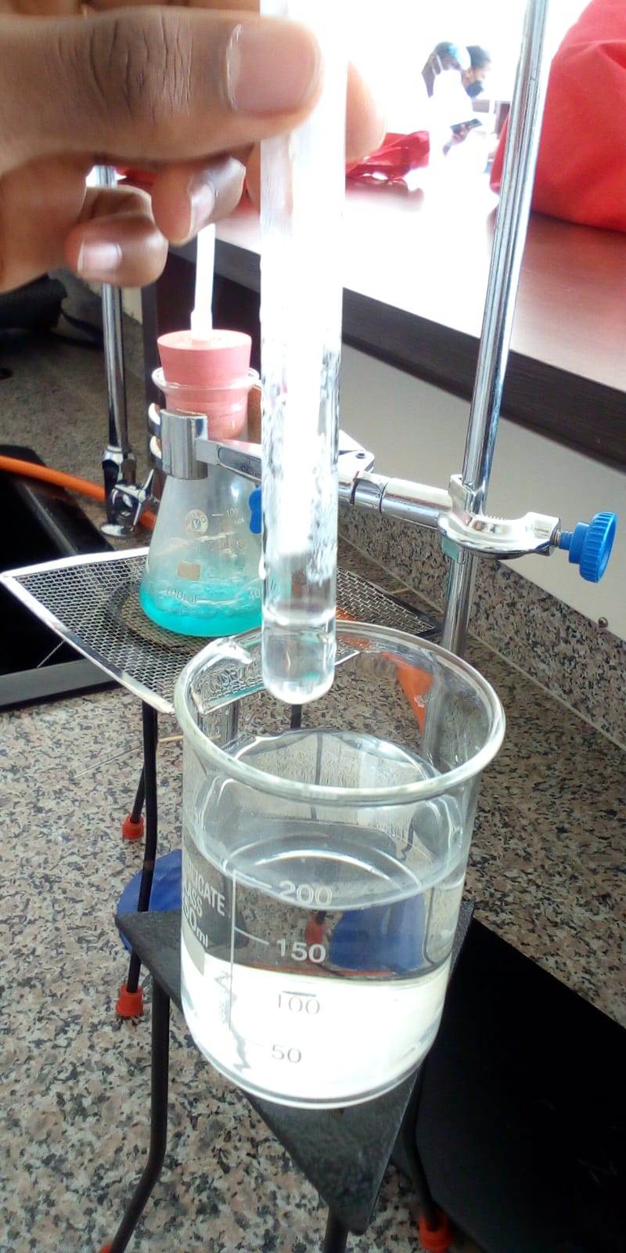
Figure 15
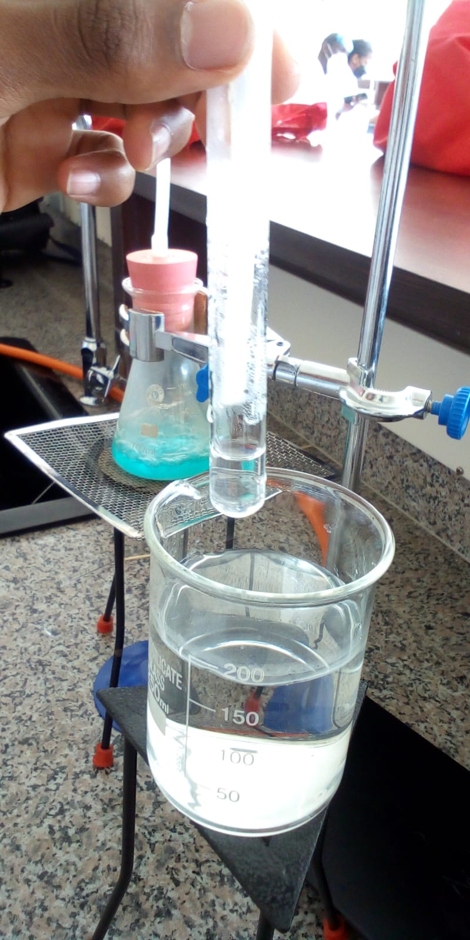
Figure 16

The water could obtained by heating copper (II)sulphate solution due to the different boiling points hence the water evaporated and condensed in the boiling tube due to the lower temperature of water in the beaker. This shows distillation of water from a mixture.

Experiment 3: Mixtures and extraction

METHODOLOGY

Requirements
Screw-top tube
Iodine solution
Petroleum ether
Dropper
wash bottle

Procedure

a) Put a screw- top tube in the test tube rack and fill it with water up to one third of its
volume.
b) Pour 3-4 drops of iodine solution and shake to obtain a homogeneous solution.
c) Pour approximately 3 ml of petroleum ether carefully with a dropper. Close the test
tube.
d) Observe the two phases before and after shaking.

RESULTS AND FINDINGS
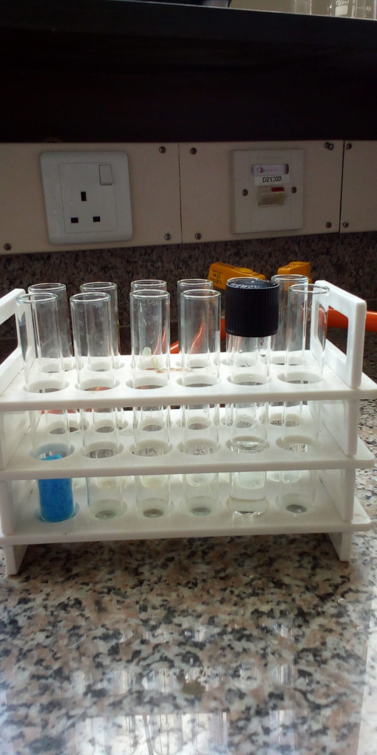
Figure 17
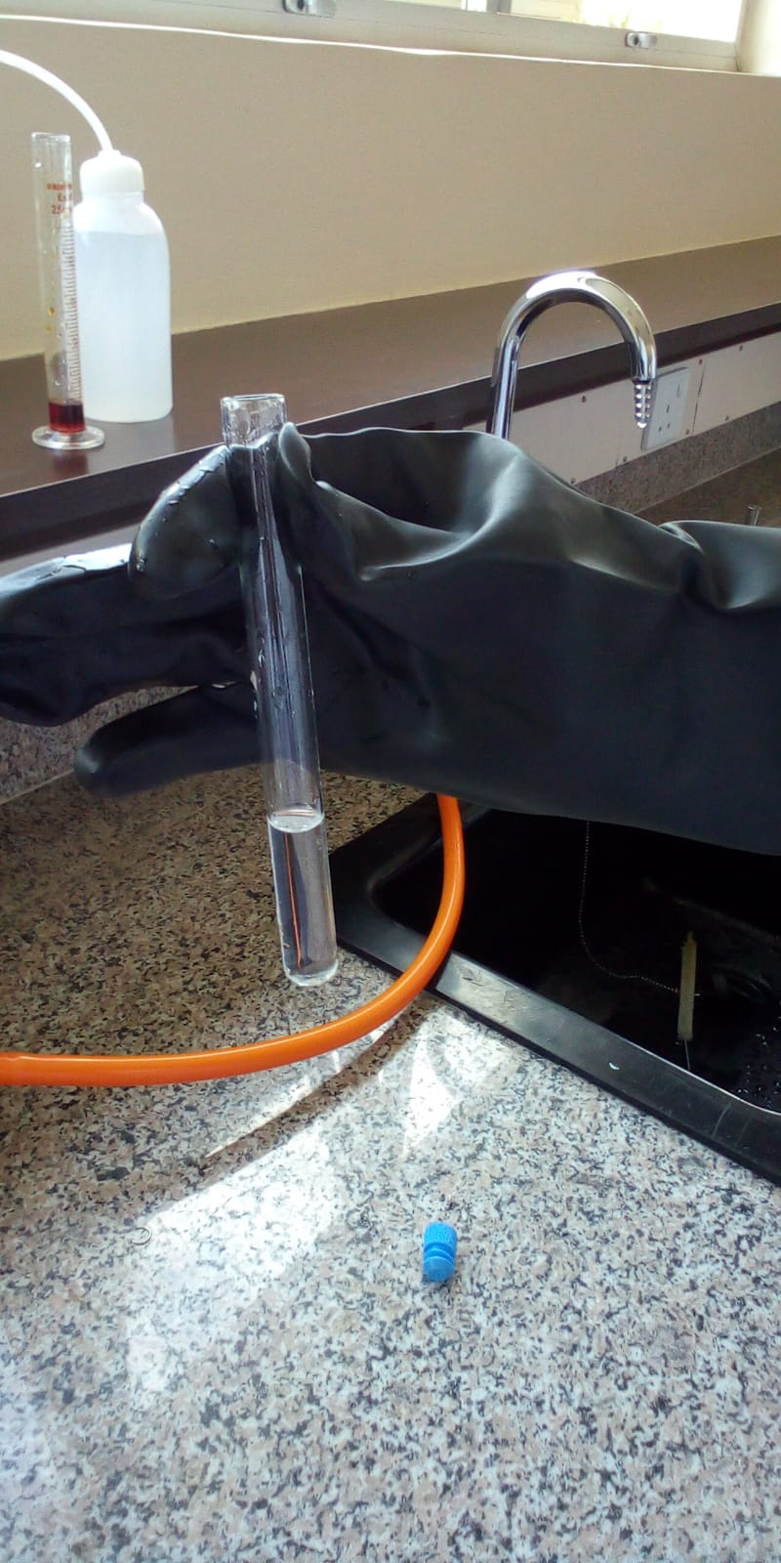
Figure 18
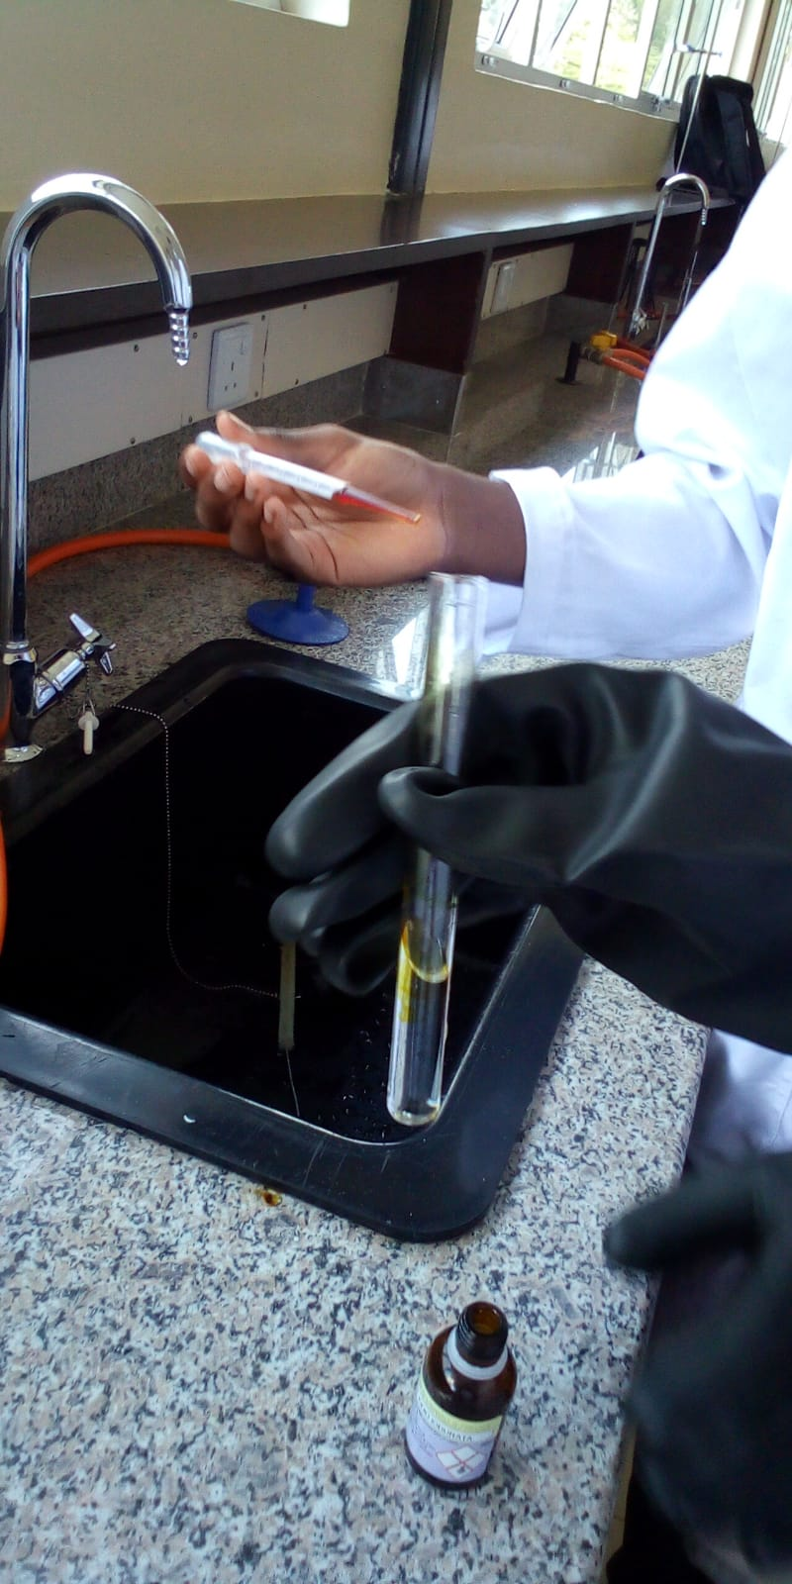
Figure 19
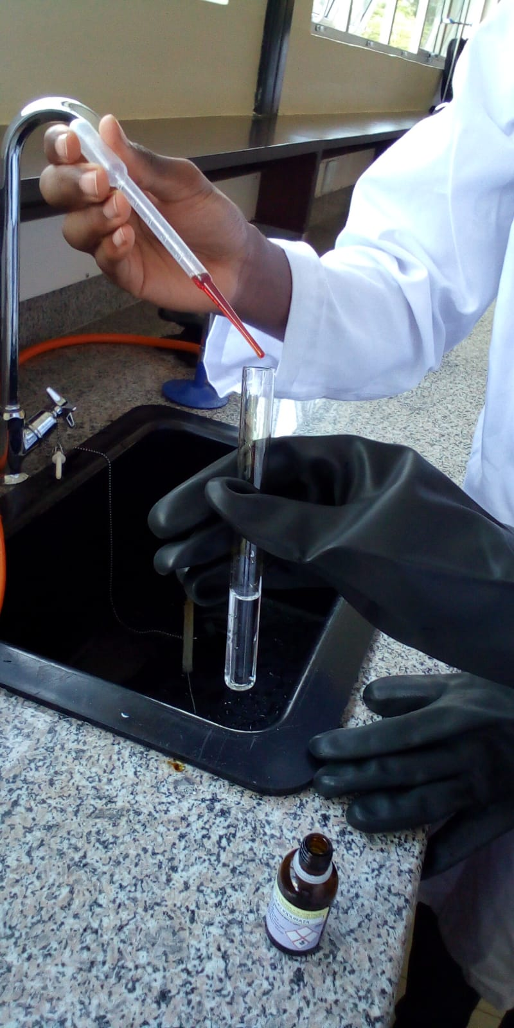
Figure 20
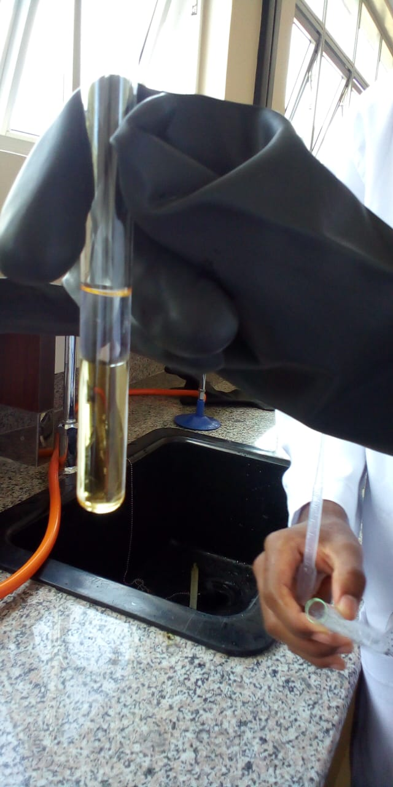
Figure 21
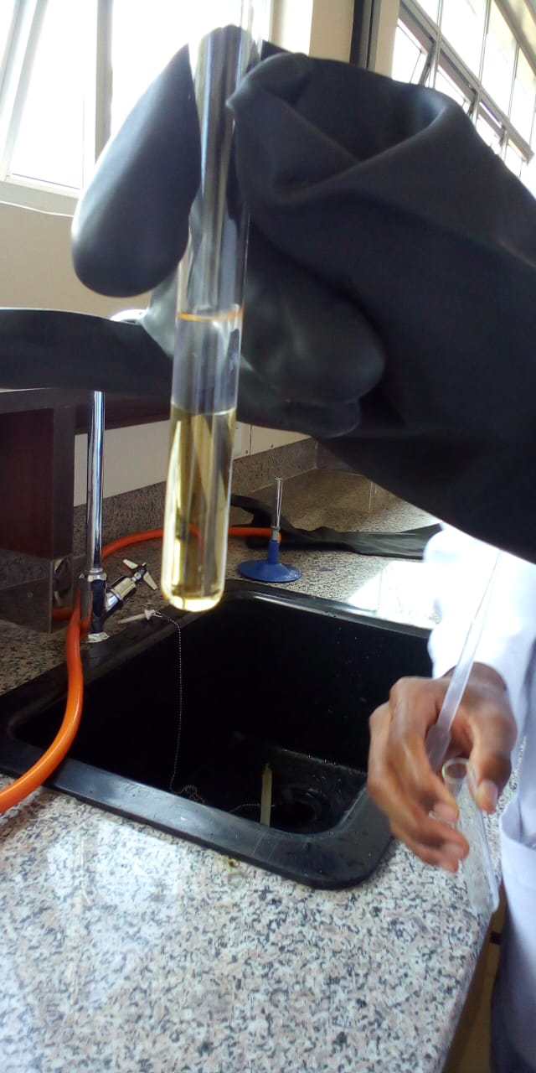
Figure 22
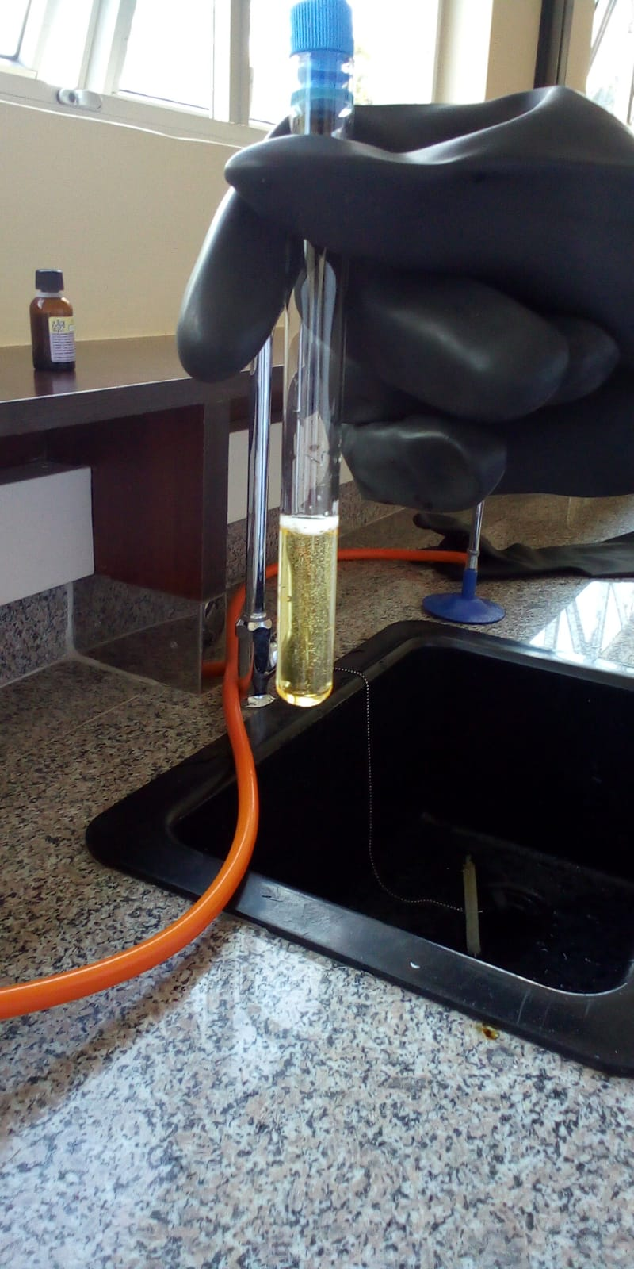
Figure 23
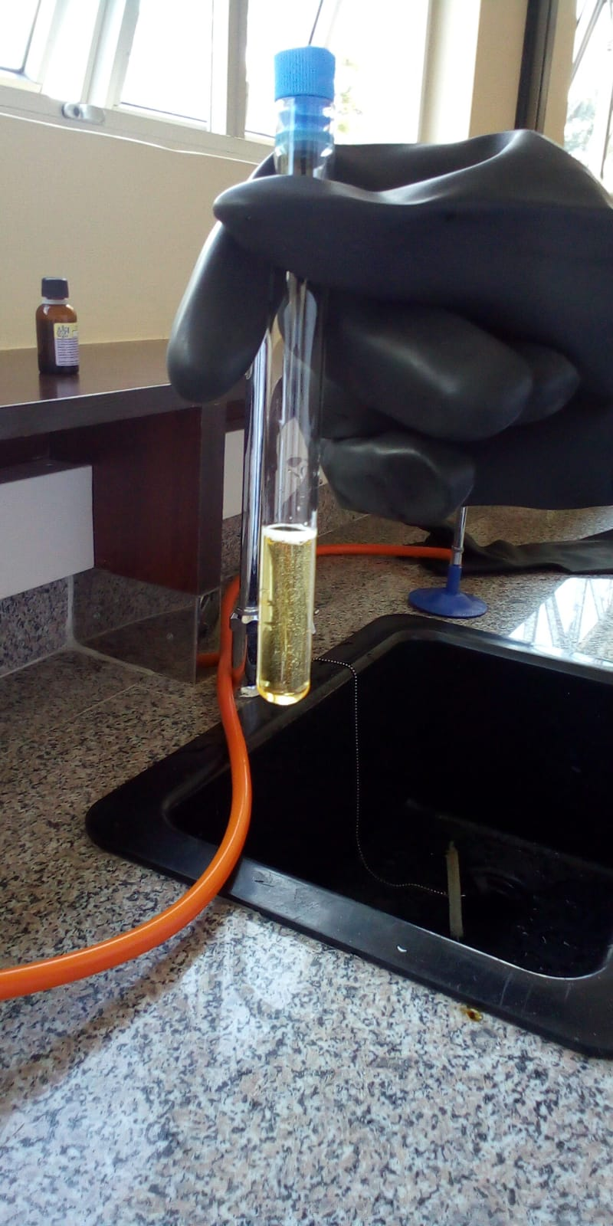
Figure 24
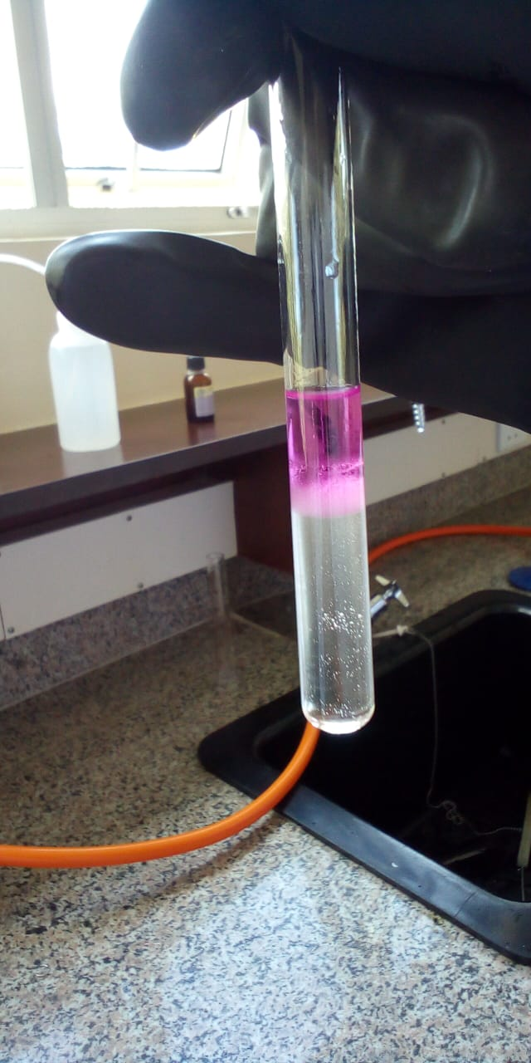
Figure 25
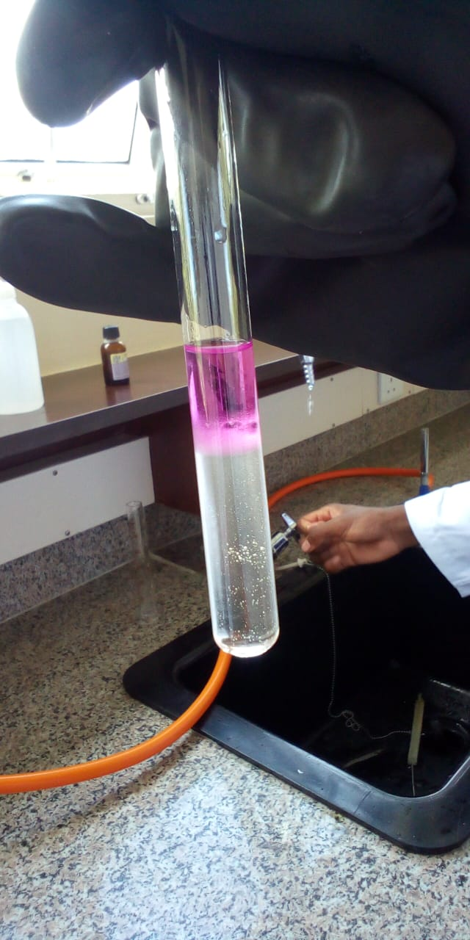
Figure 26
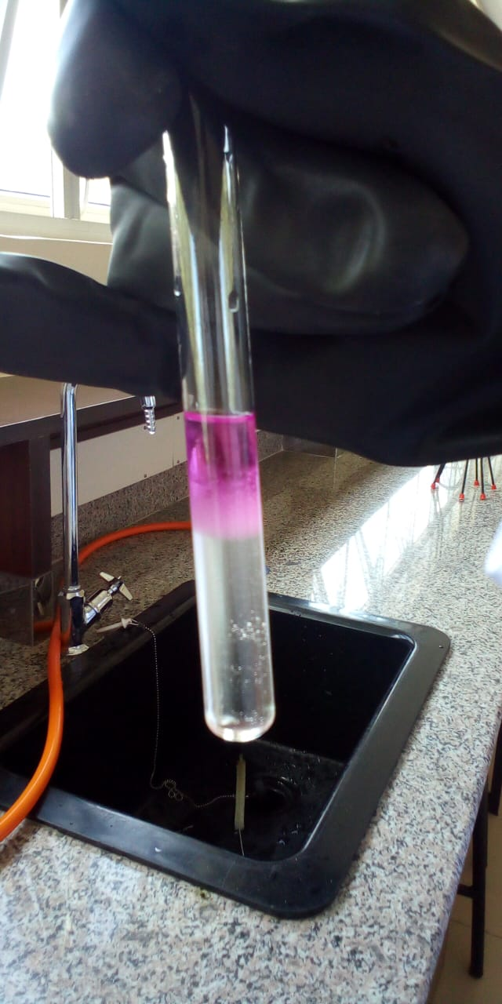
Figure 27

The petroleum ether – water mixture forms a heterogenous mixture before and after shaking due to the different densities of the liquid components. This shows that they are immiscible

REFERENCES
Crystallization—Definition, Process, Separation Technique, FAQs. (n.d.). BYJUS. Retrieved February 27, 2022, from https://byjus.com/chemistry/crystallization/
Mixture. (n.d.). VEDANTU. Retrieved February 27, 2022, from https://www.vedantu.com/chemistry/mixtures, https://www.vedantu.com/chemistry/mixtures, https://www.vedantu.com/chemistry/mixtures, https://www.vedantu.com/chemistry/mixtures
Understand How Distillation Works. (n.d.). ThoughtCo. Retrieved February 27, 2022, from https://www.thoughtco.com/what-is-distillation-601964
When Iodine (I2) is mixed with water, the water dissolves some iodine by forming a temporary charge. Does the oxygen from water bond with the Iodine or does the hydrogen? | Socratic. (n.d.). Socratic.Org. Retrieved February 27, 2022, from https://socratic.org/questions/when-iodine-i2-is-mixed-with-water-the-water-dissolves-some-iodine-by-forming-a-

